Pyramids

Definition
# Source: AI Source: Provided by: [Data Path: Persons Table -> ID Column: 1, Name_En Column: Motasem Essam] -> From: [ChatGPT] on [7/25/2026]
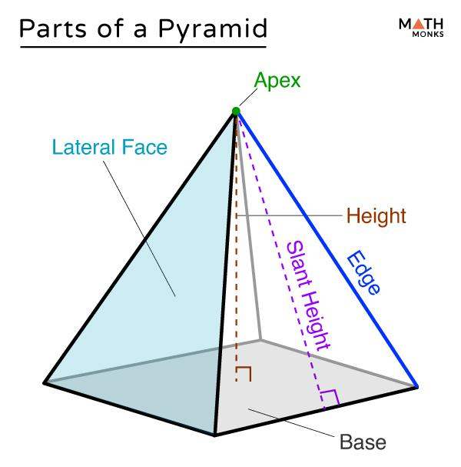
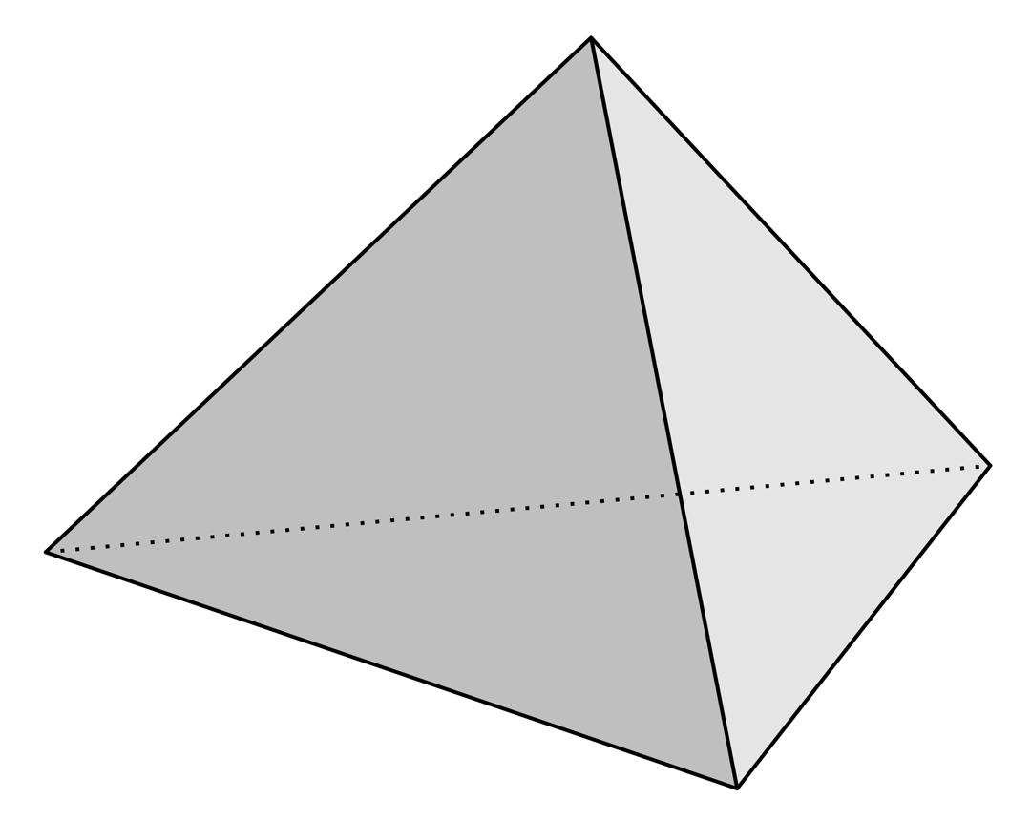
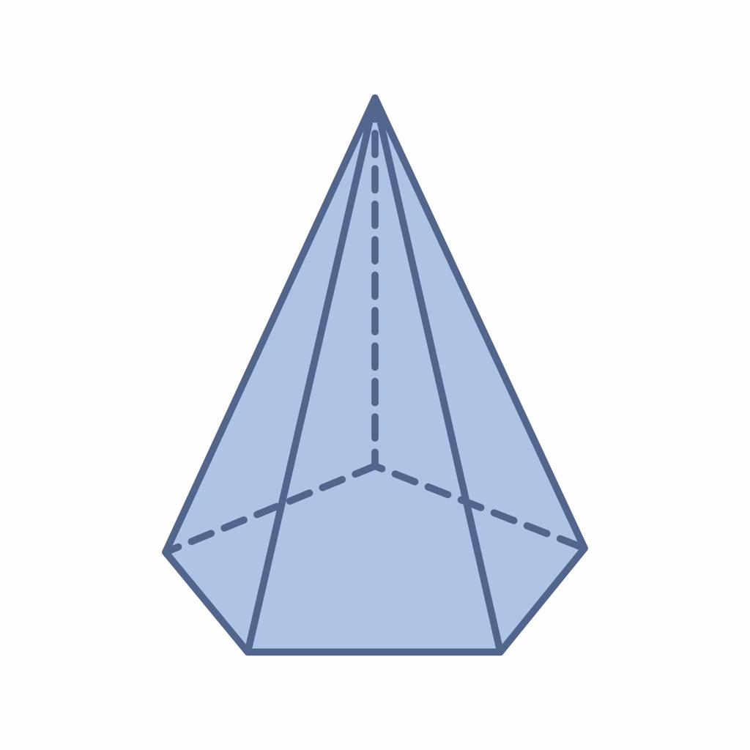
A pyramid is a polyhedron with one polygonal base and triangular lateral faces that meet at a common vertex called the apex.
The base can be any polygon, such as a triangle, square, pentagon, or hexagon. Each vertex of the base is connected to the apex by a straight lateral edge.
For a pyramid with an $n$-sided base:
- It has $1$ polygonal base.
- It has $n$ triangular lateral faces.
- It has $n+1$ faces in total.
- It has $2n$ edges.
- It has $n+1$ vertices.

Simple Definition
# Source: AI Source: Provided by: [Data Path: Persons Table -> ID Column: 1, Name_En Column: Motasem Essam] -> From: [ChatGPT] on [7/25/2026]
A pyramid is a solid with one polygonal base and triangular sides that meet at one apex.
Examples include a triangular pyramid, a square pyramid, and a pentagonal pyramid.

Classification Tree of Pyramids
# Source: AI Source: Provided by: [Data Path: Persons Table -> ID Column: 1, Name_En Column: Motasem Essam] -> From: [ChatGPT] on [7/25/2026]
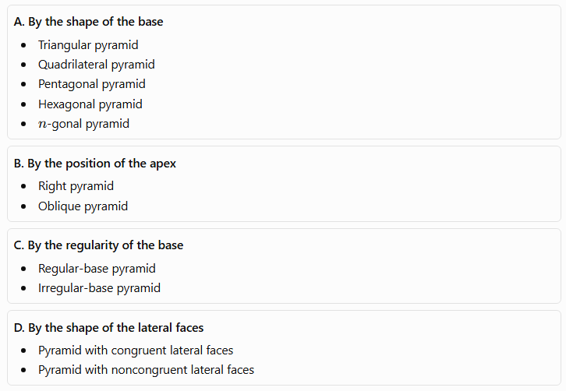
A. By the shape of the base
- Triangular pyramid
- Quadrilateral pyramid
- Pentagonal pyramid
- Hexagonal pyramid
- $n$-gonal pyramid
B. By the position of the apex
- Right pyramid
- Oblique pyramid
C. By the regularity of the base
- Regular-base pyramid
- Irregular-base pyramid
D. By the shape of the lateral faces
- Pyramid with congruent lateral faces
- Pyramid with noncongruent lateral faces
Important distinction: A pyramid with a regular polygon as its base is not automatically a regular pyramid. In the usual definition, a regular pyramid has a regular polygonal base and an apex directly above the base's center, so its lateral faces are congruent isosceles triangles.

Key Characteristics of Pyramids
# Source: AI Source: Provided by: [Data Path: Persons Table -> ID Column: 1, Name_En Column: Motasem Essam] -> From: [ChatGPT] on [7/25/2026]
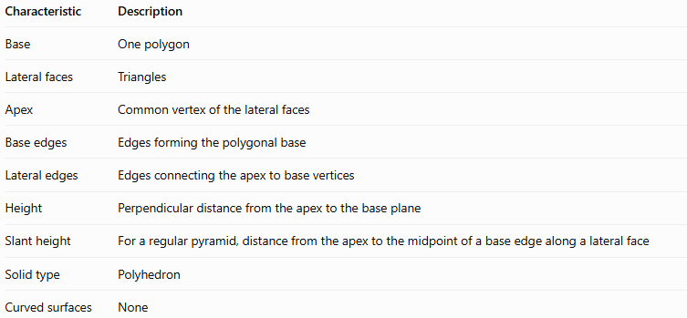
Characteristic | Description
Base | One polygon
Lateral faces | Triangles
Apex | Common vertex of the lateral faces
Base edges | Edges forming the polygonal base
Lateral edges | Edges connecting the apex to base vertices
Height | Perpendicular distance from the apex to the base plane
Slant height | For a regular pyramid, distance from the apex to the midpoint of a base edge along a lateral face
Solid type | Polyhedron
Curved surfaces | None

Types of Pyramids by Base Shape

1. Triangular Pyramid
# Source: AI Source: Provided by: [Data Path: Persons Table -> ID Column: 1, Name_En Column: Motasem Essam] -> From: [ChatGPT] on [7/25/2026]
A triangular pyramid has a triangular base and three triangular lateral faces.
- Faces: $4$
- Edges: $6$
- Vertices: $4$
A triangular pyramid is also called a tetrahedron. A regular tetrahedron has four congruent equilateral-triangle faces.
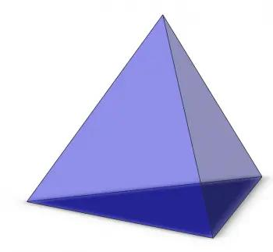

2. Quadrilateral Pyramid
# Source: AI Source: Provided by: [Data Path: Persons Table -> ID Column: 1, Name_En Column: Motasem Essam] -> From: [ChatGPT] on [7/25/2026]
A quadrilateral pyramid has a four-sided polygon as its base.
- Faces: $5$
- Edges: $8$
- Vertices: $5$
If the base is a square, it is called a square pyramid. If the base is a rectangle, it is a rectangular-based pyramid.
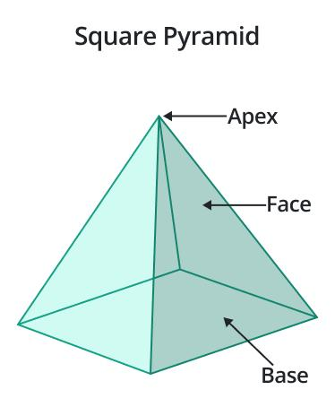

3. Pentagonal Pyramid
# Source: AI Source: Provided by: [Data Path: Persons Table -> ID Column: 1, Name_En Column: Motasem Essam] -> From: [ChatGPT] on [7/25/2026]
A pentagonal pyramid has a five-sided base and five triangular lateral faces.
- Faces: $6$
- Edges: $10$
- Vertices: $6$
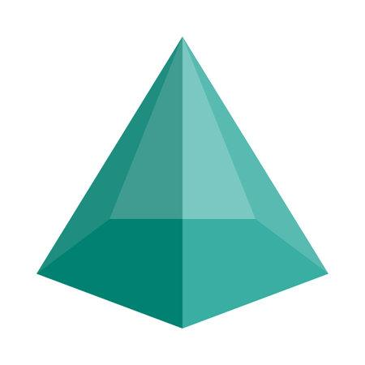

4. Hexagonal Pyramid
# Source: AI Source: Provided by: [Data Path: Persons Table -> ID Column: 1, Name_En Column: Motasem Essam] -> From: [ChatGPT] on [7/25/2026]
A hexagonal pyramid has a six-sided base and six triangular lateral faces.
- Faces: $7$
- Edges: $12$
- Vertices: $7$
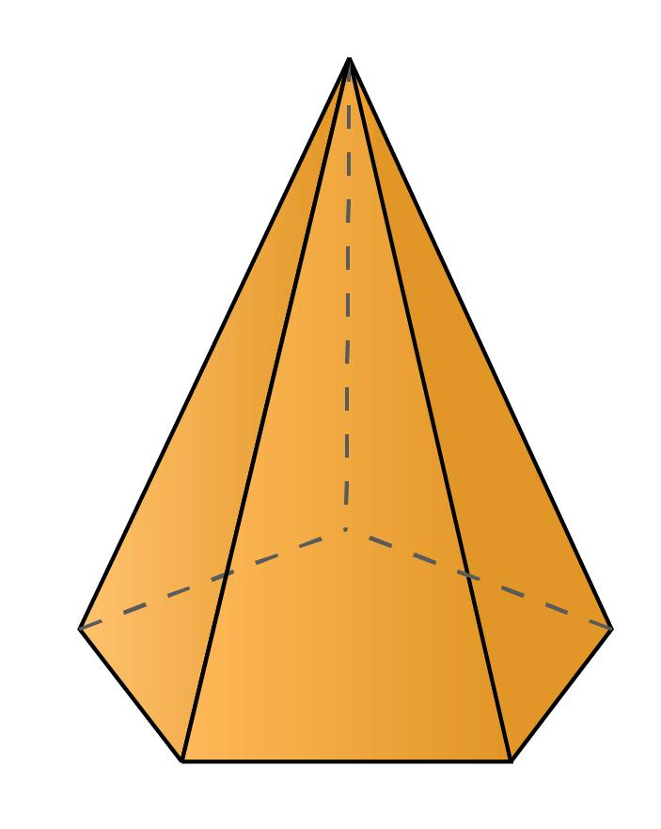

5. $n$-gonal Pyramid
# Source: AI Source: Provided by: [Data Path: Persons Table -> ID Column: 1, Name_En Column: Motasem Essam] -> From: [ChatGPT] on [7/25/2026]
An $n$-gonal pyramid has an $n$-sided polygon as its base. The number of triangular lateral faces equals the number of base edges.
Its total face, edge, and vertex counts can be calculated using general formulas.
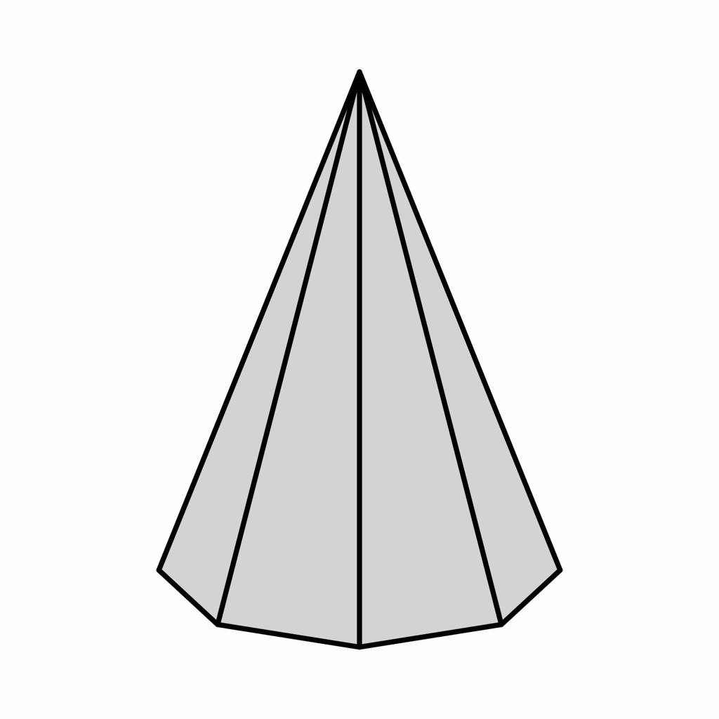
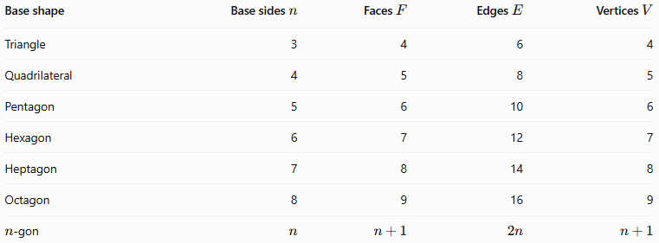
Face, edge, and vertex count table
Base shape | Base sides $n$ | Faces $F$ | Edges $E$ | Vertices $V$
Triangle | 3 | 4 | 6 | 4
Quadrilateral | 4 | 5 | 8 | 5
Pentagon | 5 | 6 | 10 | 6
Hexagon | 6 | 7 | 12 | 7
Heptagon | 7 | 8 | 14 | 8
Octagon | 8 | 9 | 16 | 9
$n$-gon | $$n$$ | $$n+1$$ | $$2n$$ | $$n+1$$

Types of Pyramids by Apex Position

1. Right Pyramid
# Source: AI Source: Provided by: [Data Path: Persons Table -> ID Column: 1, Name_En Column: Motasem Essam] -> From: [ChatGPT] on [7/25/2026]
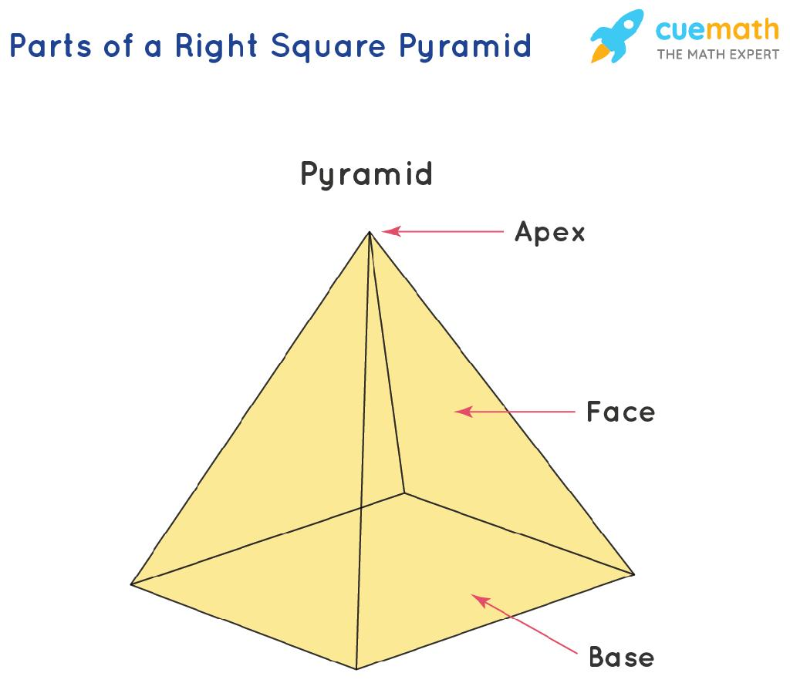
A right pyramid has its apex directly above the center of its base, provided the base is a regular polygon in the standard regular-pyramid setting. More generally, a right pyramid is defined by the perpendicular from the apex meeting the base at its center under the convention used for the chosen base.
For a regular right pyramid:
- The height is perpendicular to the base.
- The lateral edges have equal lengths.
- The lateral faces are congruent isosceles triangles.
- The slant heights of the lateral faces are equal.

2. Oblique Pyramid
# Source: AI Source: Provided by: [Data Path: Persons Table -> ID Column: 1, Name_En Column: Motasem Essam] -> From: [ChatGPT] on [7/25/2026]
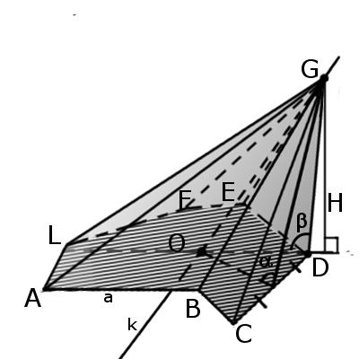
An oblique pyramid has its apex positioned so that the perpendicular from the apex to the base plane does not pass through the base's center.
Its lateral edges and lateral faces may have different lengths and areas. The perpendicular height is still measured from the apex to the base plane, not along a sloping edge.

Types by Base Regularity

Regular-base pyramid
# Source: AI Source: Provided by: [Data Path: Persons Table -> ID Column: 1, Name_En Column: Motasem Essam] -> From: [ChatGPT] on [7/25/2026]
The base is a regular polygon: all its sides and interior angles are equal.
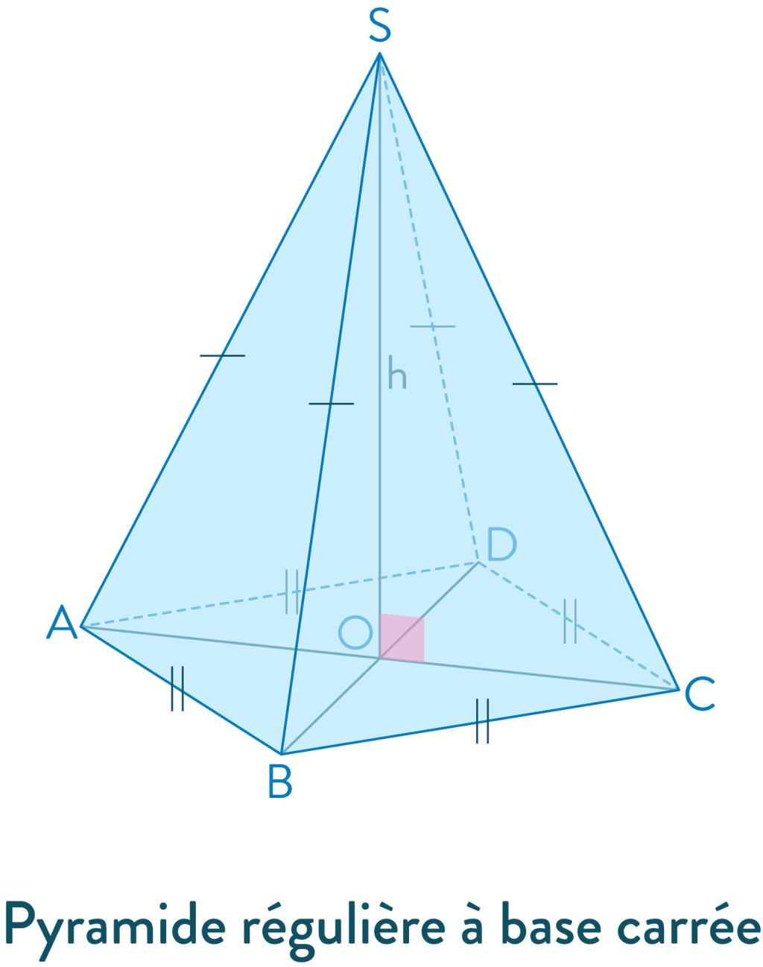

Irregular-base pyramid
# Source: AI Source: Provided by: [Data Path: Persons Table -> ID Column: 1, Name_En Column: Motasem Essam] -> From: [ChatGPT] on [7/25/2026]
The base is an irregular polygon, so its sides or angles are not all equal.
The regularity of the base is a separate property from whether the pyramid is right or oblique. For example, an oblique pyramid can have a regular polygonal base.
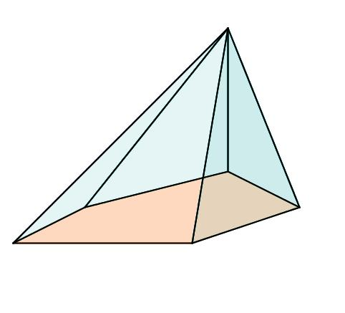

Mathematical Formulas for Pyramids
# Source: AI Source: Provided by: [Data Path: Persons Table -> ID Column: 1, Name_En Column: Motasem Essam] -> From: [ChatGPT] on [7/25/2026]
Let:
- $B$ = area of the base
- $p$ = perimeter of the base
- $h$ = perpendicular height
- $l$ = slant height of a regular pyramid
- $A_{L}$ = lateral surface area
- $A_{T}$ = total surface area
- $V$ = volume

1. Number of faces, edges, and vertices
# Source: AI Source: Provided by: [Data Path: Persons Table -> ID Column: 1, Name_En Column: Motasem Essam] -> From: [ChatGPT] on [7/25/2026]
For a pyramid with an $n$-sided base:
$$F=n+1$$
$$E=2n$$
$$V=n+1$$
These formulas count the base as one face and each triangular side as one additional face.

2. Volume
# Source: AI Source: Provided by: [Data Path: Persons Table -> ID Column: 1, Name_En Column: Motasem Essam] -> From: [ChatGPT] on [7/25/2026]
The volume of any pyramid is:
$$\boxed{V=\frac{13}{B}h}$$
The height $h$ must be perpendicular to the base plane.

3. Lateral surface area of a regular pyramid
# Source: AI Source: Provided by: [Data Path: Persons Table -> ID Column: 1, Name_En Column: Motasem Essam] -> From: [ChatGPT] on [7/25/2026]
For a regular pyramid:
$$\boxed{A_{L}=\frac{12}{p}l}$$
This formula works because each lateral face is a triangle, and the sum of the base lengths of these triangles is $p$.
For an irregular pyramid, calculate each triangular face's area and add them together.

4. Total surface area
# Source: AI Source: Provided by: [Data Path: Persons Table -> ID Column: 1, Name_En Column: Motasem Essam] -> From: [ChatGPT] on [7/25/2026]
$$\boxed{A_{T}=B+A_{L}}$$
The total surface area is the base area plus the areas of all lateral faces.

5. Slant height of a regular right pyramid
# Source: AI Source: Provided by: [Data Path: Persons Table -> ID Column: 1, Name_En Column: Motasem Essam] -> From: [ChatGPT] on [7/25/2026]
If $r$ is the apothem of the regular base, then:
$$\boxed{l=\sqrt{h^{2}+r^{2}}}$$
This follows from the Pythagorean theorem. Here, $r$ is the distance from the center of the base to the midpoint of one of its sides, not the distance to a base vertex.
For a square pyramid with base side $a$, $r=\frac{a}{2}$, so:
$$l=\sqrt{h^{2}+{\left(\frac{a}{2}\right)}^{2}}$$

Worked Examples
# Source: AI Source: Provided by: [Data Path: Persons Table -> ID Column: 1, Name_En Column: Motasem Essam] -> From: [ChatGPT] on [7/25/2026]
Example 1: Counting the elements of a pentagonal pyramid
Problem: Find the number of faces, edges, and vertices of a pentagonal pyramid.
Step 1: Identify the base.
A pentagon has $n=5$ sides.
Step 2: Calculate the faces.
$$F=n+1=5+1=\boxed{6}$$
Step 3: Calculate the edges.
$$E=2n=2\left(5\right)=\boxed{10}$$
Step 4: Calculate the vertices.
$$V=n+1=5+1=\boxed{6}$$
Answer: The pyramid has 6 faces, 10 edges, and 6 vertices.
Example 2: Calculating the volume of a square pyramid
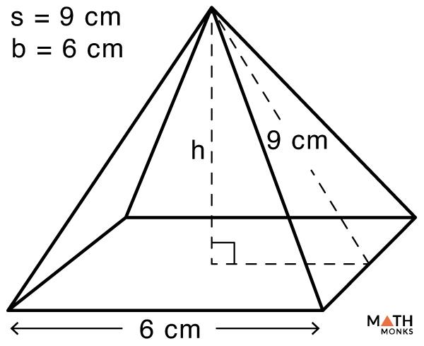
Problem: A square pyramid has a base side of $6\text{ cm}$ and a perpendicular height of $9\text{ cm}$. Find its volume.
The base area is:
$$B=6^{2}=36{\text{ cm}}^{2}$$
Using the volume formula:
$$V=\frac{13}{B}h$$
$$V=\frac{13}{\left(36\right)}\left(9\right)$$
$$\boxed{V=108{\text{ cm}}^{3}}$$
Answer: The volume is $108{\text{ cm}}^{3}$.
Example 3: Calculating the surface area of a regular square pyramid
Problem: A regular square pyramid has a base side of $8\text{ cm}$ and a slant height of $5\text{ cm}$. Find its total surface area.
Step 1: Calculate the base area.
$$B=8^{2}=64{\text{ cm}}^{2}$$
Step 2: Calculate the base perimeter.
$$p=4\left(8\right)=32\text{ cm}$$
Step 3: Calculate the lateral surface area.
$$A_{L}=\frac{12}{p}l$$
$$A_{L}=\frac{12}{\left(32\right)}\left(5\right)=80{\text{ cm}}^{2}$$
Step 4: Calculate the total surface area.
$$A_{T}=B+A_{L}$$
$$A_{T}=64+80$$
$$\boxed{A_{T}=144{\text{ cm}}^{2}}$$
Answer: The total surface area is $144{\text{ cm}}^{2}$.
Example 4: Finding the height from the slant height
Problem: A regular right square pyramid has a base side of $10\text{ cm}$ and a slant height of $13\text{ cm}$. Find its perpendicular height.
For a square base, the apothem is:
$$r=\frac{10}{2}=5\text{ cm}$$
Using the Pythagorean relationship:
$$l^{2}=h^{2}+r^{2}$$
$${13}^{2}=h^{2}+5^{2}$$
$$h^{2}=169-25=144$$
$$\boxed{h=12\text{ cm}}$$
Answer: The perpendicular height is $12\text{ cm}$.

Euler's Formula for Pyramids
# Source: AI Source: Provided by: [Data Path: Persons Table -> ID Column: 1, Name_En Column: Motasem Essam] -> From: [ChatGPT] on [7/25/2026]
Every convex pyramid satisfies Euler's polyhedron formula:
$$V-E+F=2$$
For an $n$-gonal pyramid:
$$V=n+1, E=2n, F=n+1$$
Substitute these expressions:
$$\left(n+1\right)-2n+\left(n+1\right)=2$$
$$\boxed{V-E+F=2}$$
For example, a square pyramid has $V=5$, $E=8$, and $F=5$:
$$5-8+5=2$$
This confirms Euler's formula.

Constructing Pyramids in Solid Geometry

Geometric Instruments Used
# Source: AI Source: Provided by: [Data Path: Persons Table -> ID Column: 1, Name_En Column: Motasem Essam] -> From: [ChatGPT] on [7/25/2026]
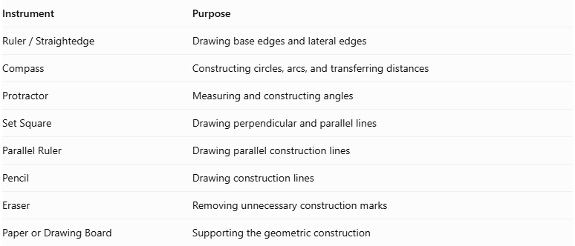
Instrument | Purpose
$$Ruler/Straightedge$$ | Drawing base edges and lateral edges
Compass | Constructing circles, arcs, and transferring distances
Protractor | Measuring and constructing angles
Set Square | Drawing perpendicular and parallel lines
Parallel Ruler | Drawing parallel construction lines
Pencil | Drawing construction lines
Eraser | Removing unnecessary construction marks
Paper or Drawing Board | Supporting the geometric construction

Instrument-Based Construction Procedures

Constructing the Polygonal Base
# Source: AI Source: Provided by: [Data Path: Persons Table -> ID Column: 1, Name_En Column: Motasem Essam] -> From: [ChatGPT] on [7/25/2026]
- Select the required polygonal base.
- Use a ruler, compass, and protractor as appropriate to construct the polygon.
- Mark all its vertices and edges.
- Ensure that the polygon has the required dimensions and angles.

Locating the Apex
# Source: AI Source: Provided by: [Data Path: Persons Table -> ID Column: 1, Name_En Column: Motasem Essam] -> From: [ChatGPT] on [7/25/2026]
- Determine the intended position of the apex.
- For a right pyramid, locate the base center.
- Draw a perpendicular construction line from the base plane through the intended apex position.
- For an oblique pyramid, select an apex position that does not lie directly above the base center.
- Mark the apex at the required height.

Connecting the Apex to the Base Vertices
# Source: AI Source: Provided by: [Data Path: Persons Table -> ID Column: 1, Name_En Column: Motasem Essam] -> From: [ChatGPT] on [7/25/2026]
- Identify all vertices of the polygonal base.
- Connect each base vertex to the apex using a straightedge.
- Ensure that each connection forms a lateral edge.
- Verify that every base edge is associated with one triangular lateral face.

Completing the Pyramid
# Source: AI Source: Provided by: [Data Path: Persons Table -> ID Column: 1, Name_En Column: Motasem Essam] -> From: [ChatGPT] on [7/25/2026]
- Draw the base polygon and all lateral edges.
- Identify the visible and hidden faces.
- Use solid lines for visible edges.
- Use dashed lines for hidden edges when necessary.
- Check that all triangular lateral faces meet at the same apex.

Constructing a Right Pyramid
# Source: AI Source: Provided by: [Data Path: Persons Table -> ID Column: 1, Name_En Column: Motasem Essam] -> From: [ChatGPT] on [7/25/2026]
- Construct the required polygonal base.
- Determine the center of the base using suitable geometric constructions.
- Construct a perpendicular line to the base plane through its center.
- Mark the apex at the required height along this perpendicular.
- Connect the apex to every base vertex.
- Complete the triangular lateral faces.

Constructing an Oblique Pyramid
# Source: AI Source: Provided by: [Data Path: Persons Table -> ID Column: 1, Name_En Column: Motasem Essam] -> From: [ChatGPT] on [7/25/2026]
- Construct the required polygonal base.
- Select an apex position away from the perpendicular line through the base center.
- Construct the apex at the required height above the base plane.
- Connect the apex to every base vertex.
- Complete the triangular lateral faces.
- Distinguish visible and hidden edges.

Constructing a Pyramid Using a Net
# Source: AI Source: Provided by: [Data Path: Persons Table -> ID Column: 1, Name_En Column: Motasem Essam] -> From: [ChatGPT] on [7/25/2026]
- Construct the polygonal base.
- Construct one triangular lateral face for each base edge.
- Ensure that each triangle has the correct base-edge length and lateral-edge lengths.
- Arrange the triangles around the base so that their edges match the corresponding base edges.
- Fold the triangles upward.
- Join their lateral edges to form the common apex.

Pyramid Compared with Other Solids
# Source: AI Source: Provided by: [Data Path: Persons Table -> ID Column: 1, Name_En Column: Motasem Essam] -> From: [ChatGPT] on [7/25/2026]
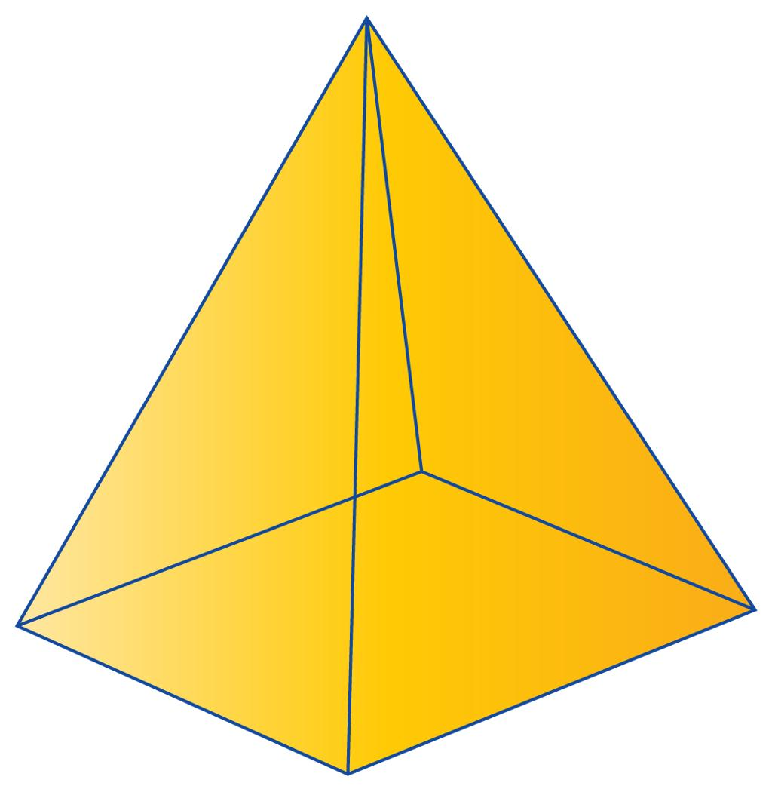
Pyramid
- One polygonal base.
- Triangular lateral faces meet at one apex.
- Has $n+1$ faces for an $n$-sided base.
Prism
- Two congruent, parallel polygonal bases.
- Lateral faces are parallelograms.
- Has $n+2$ faces for an $n$-sided base.
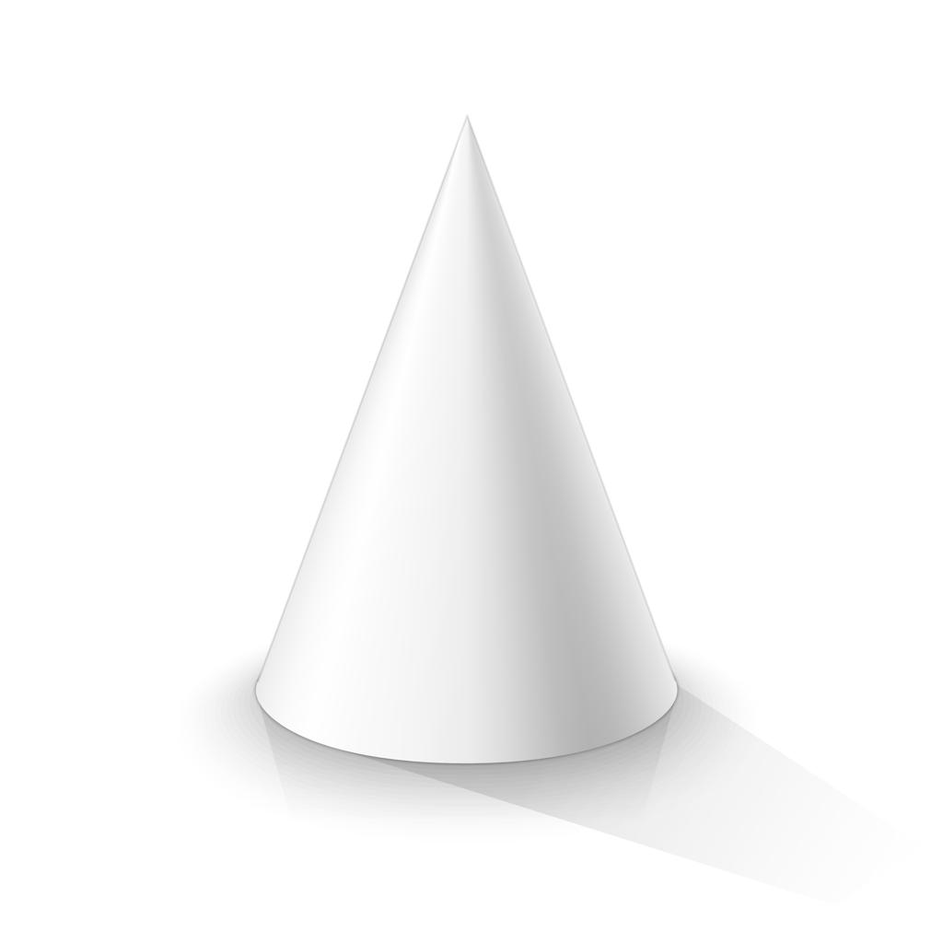
Cone
- One circular base.
- One curved lateral surface.
- Has a circular rim and one apex, but it is not a polyhedron.
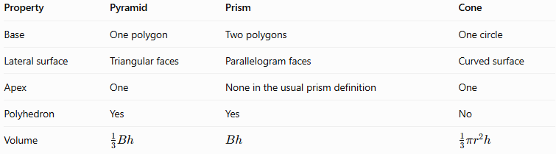
Property | Pyramid | Prism | Cone
Base | One polygon | Two polygons | One circle
Lateral surface | Triangular faces | Parallelogram faces | Curved surface
Apex | One | None in the usual prism definition | One
Polyhedron | Yes | Yes | No
Volume | $$\frac{1}{3}Bh$$ | $$Bh$$ | $$\frac{1}{3}πr^{2}h$$

Applications of Pyramids
# Source: AI Source: Provided by: [Data Path: Persons Table -> ID Column: 1, Name_En Column: Motasem Essam] -> From: [ChatGPT] on [7/25/2026]
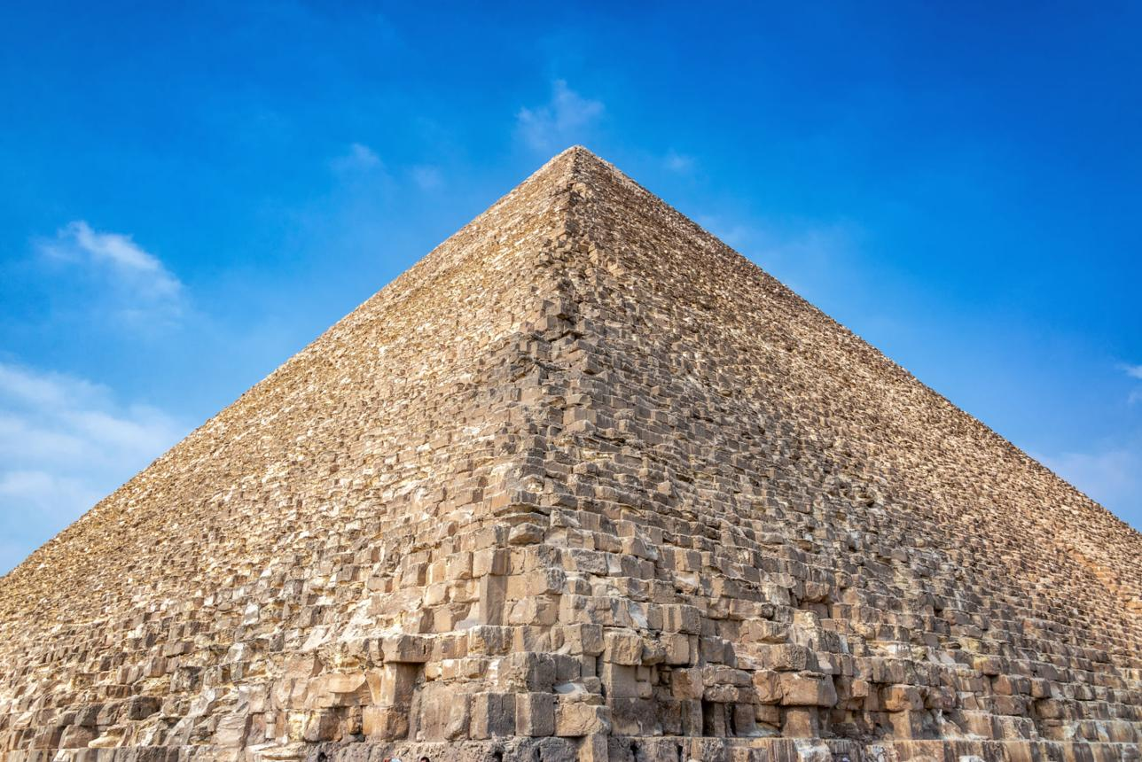
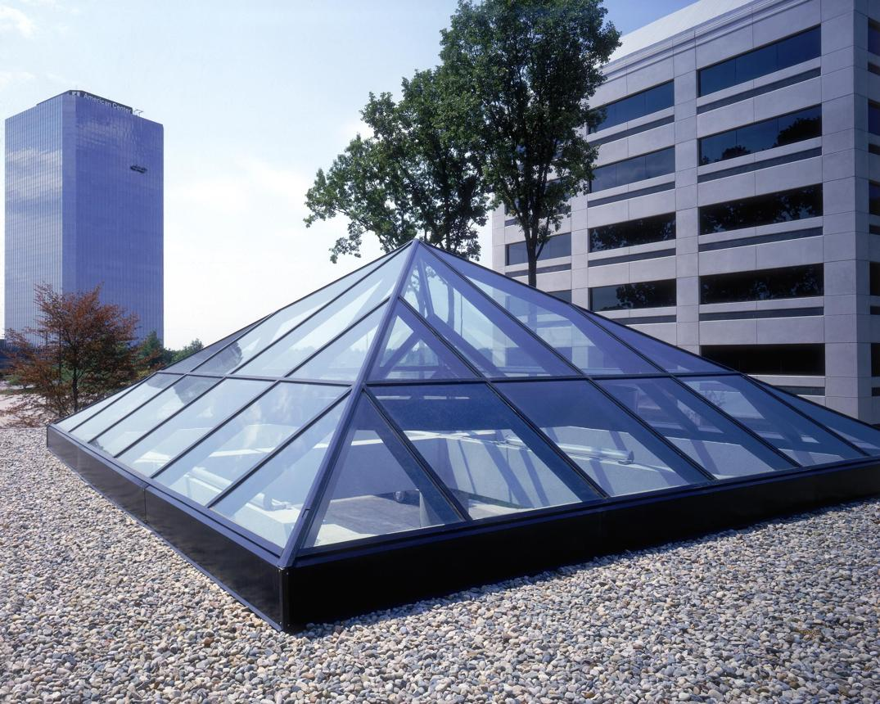
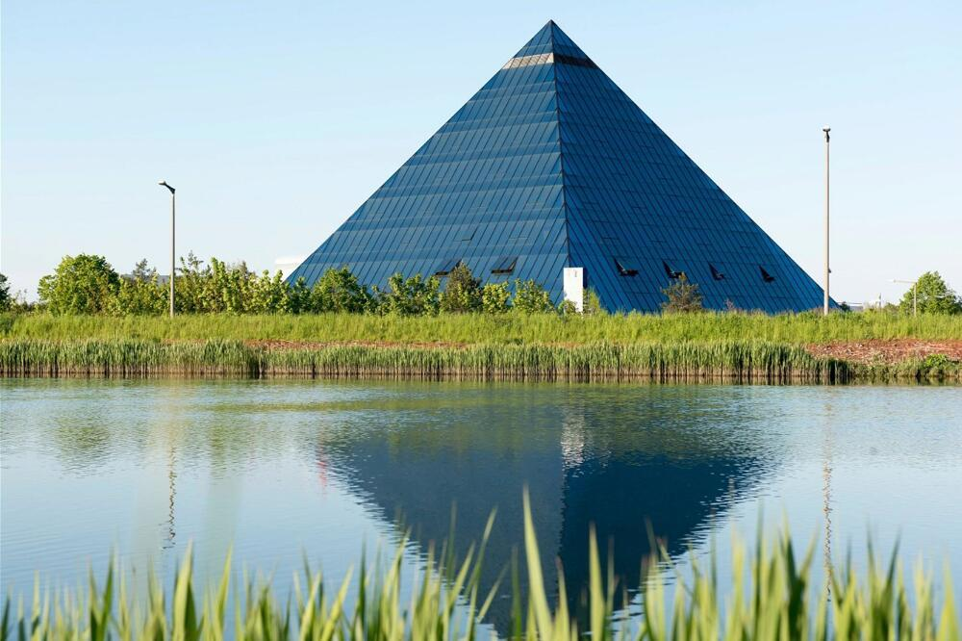
Pyramidal shapes appear in many practical settings:
- Architecture: pyramid-shaped roofs, monuments, and decorative structures.
- Engineering: structures designed around triangular surfaces and converging supports.
- Packaging: containers and packages with pyramid-shaped forms.
- Mathematics education: studying polygons, surface area, volume, and spatial relationships.
- Computer graphics: modeling three-dimensional objects using vertices, edges, and faces.

Key Points
# Source: AI Source: Provided by: [Data Path: Persons Table -> ID Column: 1, Name_En Column: Motasem Essam] -> From: [ChatGPT] on [7/25/2026]
- A pyramid is a polyhedron with one polygonal base and triangular lateral faces.
- All lateral faces meet at a common vertex called the apex.
- An $n$-gonal pyramid has $n+1$ faces, $2n$ edges, and $n+1$ vertices.
- A right pyramid and an oblique pyramid differ in the position of the apex relative to the base.
- A regular pyramid has a regular polygonal base and, in the standard definition, its apex lies above the base center.
- The volume is $V=\frac{1}{3}Bh$.
- For a regular pyramid, the lateral surface area is $A_{L}=\frac{1}{2}pl$.
- Convex pyramids satisfy Euler's formula, $V-E+F=2$.

Conclusion
# Source: AI Source: Provided by: [Data Path: Persons Table -> ID Column: 1, Name_En Column: Motasem Essam] -> From: [ChatGPT] on [7/25/2026]
Pyramids are an important class of polyhedra distinguished by a single polygonal base and triangular lateral faces that converge at an apex. They can be classified by their base shape, apex position, and regularity. Understanding their face, edge, and vertex counts, along with their volume and surface-area formulas, provides a foundation for studying more complex three-dimensional geometry.

